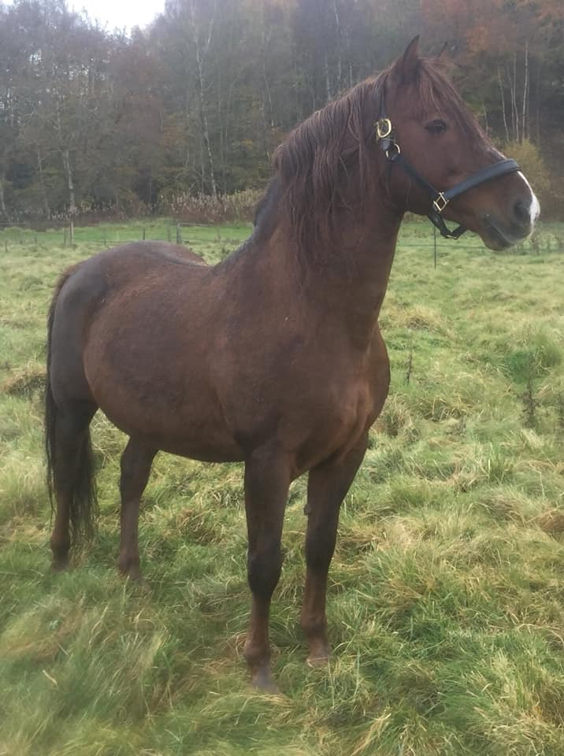

Briarpatch Phoenix

15.2hh Chestnut Stallion
Stands natural service in Scotland or frozen semen to Europe
For more information
Contact Ashleigh Buck on 07383 108279
Old lines in first 5 generations, Pecos, Orcland Leader, UVM Promise, Easter Twilight, Cornwallis

