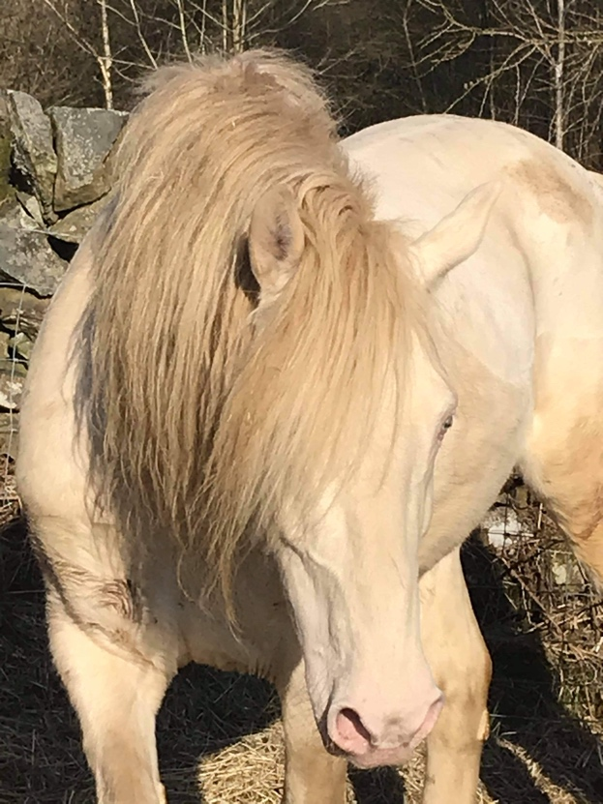
Briarpatch Sea Hawk – ‘ Storm’
Selah Victor Allen x Caylyn Bold as Brass

14.1 Perlino Stallion. Foundation bred
Stands Live cover in Scotland or frozen semen to Europe

For more information contact Ash Buck on 07383 108279; ash.buck2@gail.com
Facebook AB Morgans and Sport Horses.

