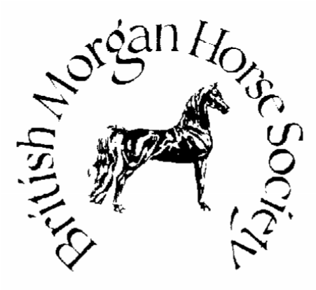

BMHS World & Rare Breed Show, 23rd July 2022

I…………………………………………... agree to donate £30.00 to sponsor a class at the BMHS World & Rare Breed Show in July 2022.

Please provide full contact details and print the Sponsor’s name exactly as you would like it to appear in the schedule or on rosettes.
DO YOU REQUIRE AN INVOICE FOR THIS SPONSORSHIP? YES / NO
(please circle and provide full address below)

………………………………………………………………………………………………………………………

Address: …………………………………………………………………………………………………………………..

Tel No:………………………………………………Email……………………………………………………………….

Signed…………………………………….……..….Date…………………………………

Which class would you like to sponsor?...................................................................................
CLASS NUMBER………………..

Please return all correspondence to: BACS payments to:

Nicola Martin
16 Burgess Green Sort Code: 20-53-22
Hacklinge, Deal Kent CT14 0AW Account: 00129763
nasnicky@yahoo.co.uk Name: British Morgan Horse Society

PayPal: treasurer@morganhorse.org.uk

Please use your class number as reference for payment

AMOUNT PAID…..£…………………..

